Exp 1: Simulation and Comparative
Performance Evaluation of Zigbee, 6LoWPAN and NB-IoT Communication Protocols for IoE Applications

Objectives:To simulate and compare the performance of Zigbee, 6LoWPAN, and NB-IoT communication protocols for Internet of Everything (IoE) applications based on parameters such as data rate, latency, energy consumption, communication range, and reliability
Procedure :
- Select a suitable simulation tool and configure the network environment for Zigbee, 6LoWPAN, and NB-IoT protocols.
- Create the network topology by configuring nodes, gateways, and communication links for each protocol.
- Simulate data transmission between IoE devices using the three communication protocols under similar conditions.
- Measure and record the performance parameters, including throughput, latency, energy consumption, and packet delivery ratio.
- Compare the simulation results and identify the most suitable protocol for different IoE applications based on its performance.
Table column:
 | ZIGBEE | 6LoWPAN | NB-IoT
Pt(dBm) | 0 | 0 | 23
PL0(dB) | 40 | 40 | 31
N | 3.0 | 3.0 | 3.5
N(dBm) | -105 | -105 | -105
BER | 3.029e^-174 | 3.540e^-53 | 0.0036
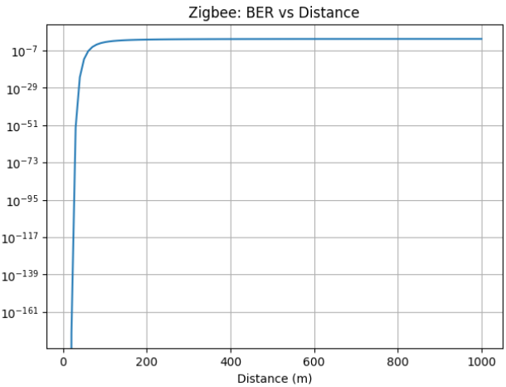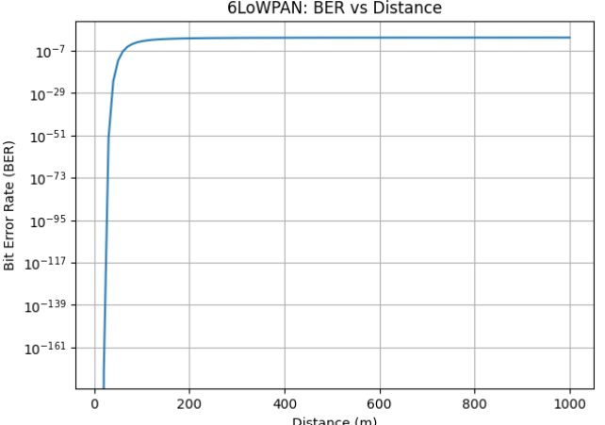

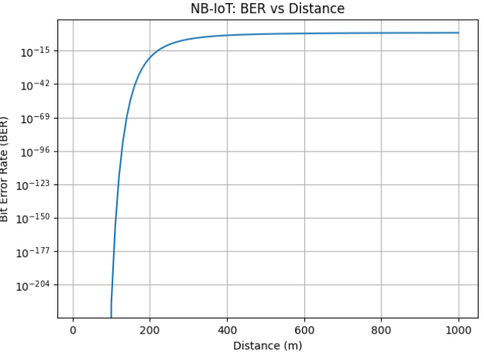
 | ZIGBEE | 6LoWPAN | NB-IoT
Pt(dBm) | 0 | 0 | 23
PL0(dB) | 40 | 40 | 31
N | 3.0 | 3.0 | 3.5
N(dBm) | -98 | -98 | -98
BER | 1.7642e^-36 | 4.0578^-12 | 0.115

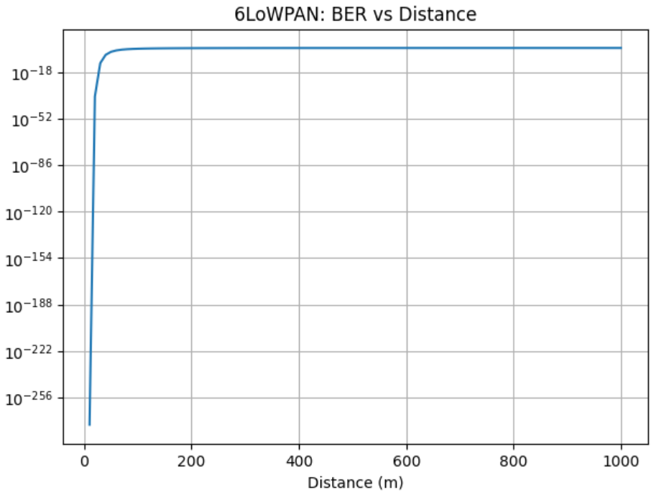
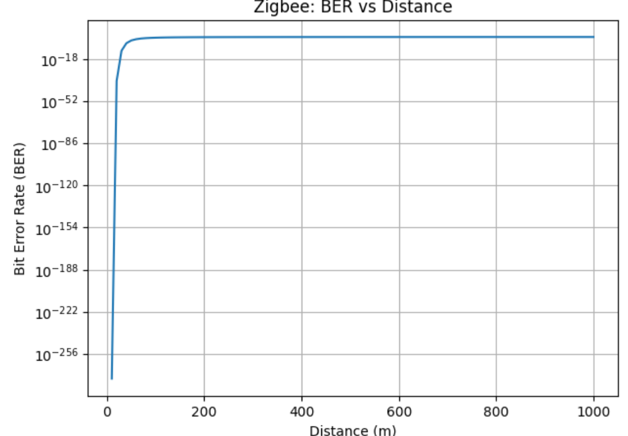
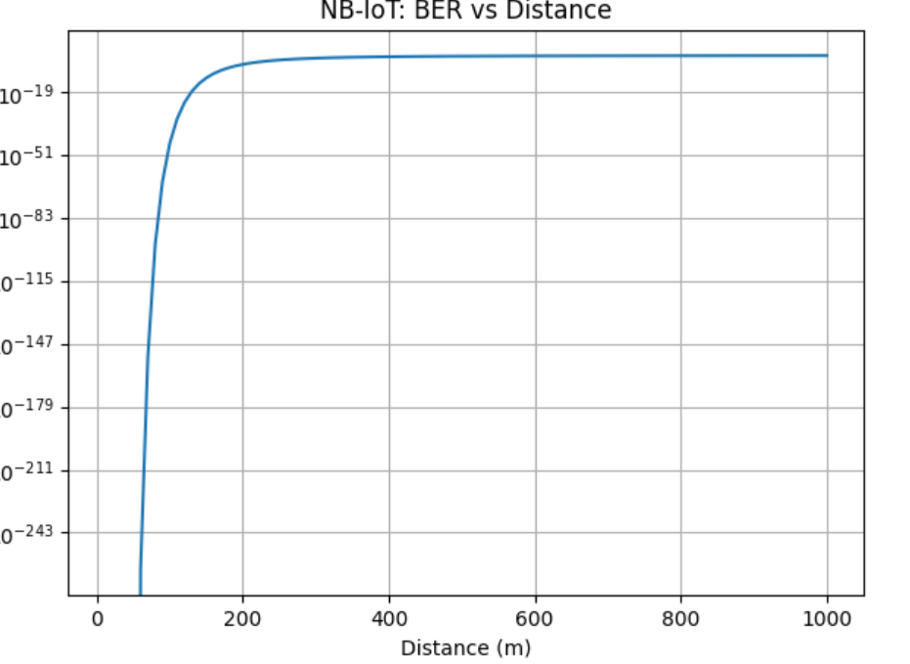
 | ZIGBEE | 6LoWPAN | NB-IoT
Pt(dBm) | 0 | 0 | 23
PL0(dB) | 40 | 40 | 31
N | 3.0 | 3.0 | 3.5
N(dBm) | -104 | -104 | -104
BER | 6.901^-136 | 1.148e^-42 | 0.0084
